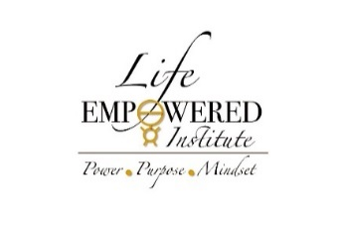
LEI Products and Commission
The following programs are commissionable paid by the company (LEI) and or the LEI Associate Consultant acting as a licensed Referral Partner under the terms of the Affiliate Referral Partner.

- LEI – PGI-Thinking Into Results-12 Lesson Program
  - 15%
- LEI – Vision Your Future Now-Series 1 Program-With Facilitation
  - 25%
- LEI – PRAXIS Membership Program
  - 30%
- LEI- PREVIEW LESSON 1 PGI -TIR
  - 25%
- LEI Associate Consultant Program including TIR
  - 16%
- LEI – Affiliate Referral Partner Enrollment
  - 35%

Signature LEIAR: ______________________ Date: ________

LEI or LEIAC: _________________________ Date: ________

